Transferring Components to an Outside Vendor for Assembly.

In summary, you create an order for an assembled set, then ship the components to another vendor to assemble. The original order only shows the finished goods item for the assembled set.

This process will automatically create an extra order for just the components as a transfer order.

Once your plant manufactures the components, you release the components from the extra Order to the bill of lading.

Posting the Bill of Lading creates finished goods transfers.

STEP 1  Menu I-F-4

First you must create a new Warehouse for your Vendor such as GW for Goodwill.

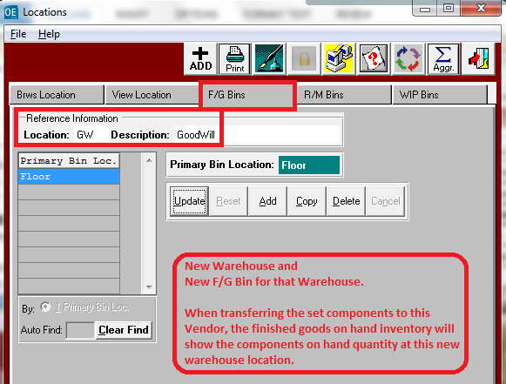

STEP 2  Menu A-F-8

Create Truck Code for new Location.  Ie. Goodwill

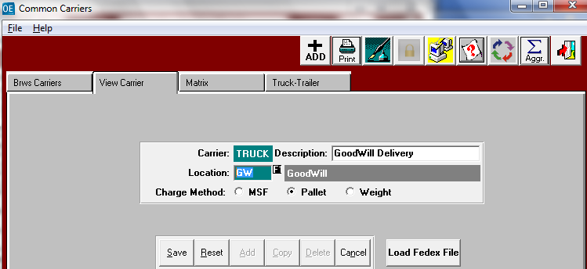

STEP 3  Menu A-F-1  Add new Customer Ship To

Add new SHIPTO Location under your Company.    
You must put the New Warehouse GW and the New Truck in this Ship To Location.

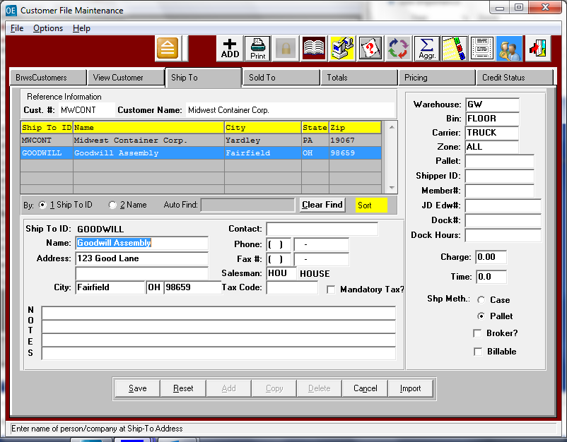

STEP 4  Menu  N-K-1

Set NK1 OESetXfor Logical Value = YES.

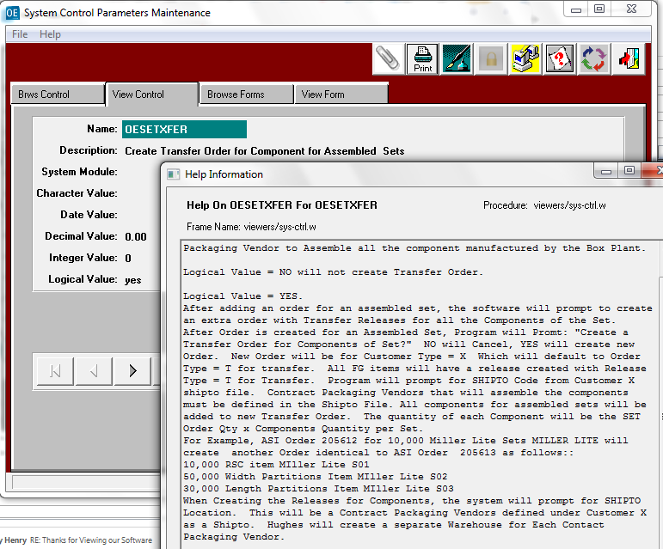

STEP 5  Menu O-U-1   Add Order for Assembled Sets

Once Order is added for the Assembled Sets, the following prompt will appear to create an extra order the only lists the components. Each component will be a TRANSFER release via this extra order.

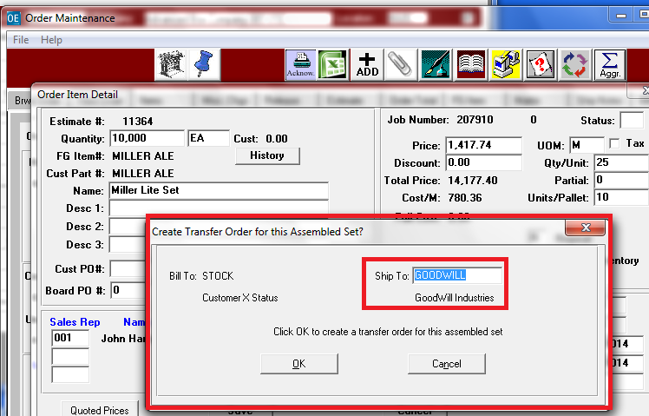

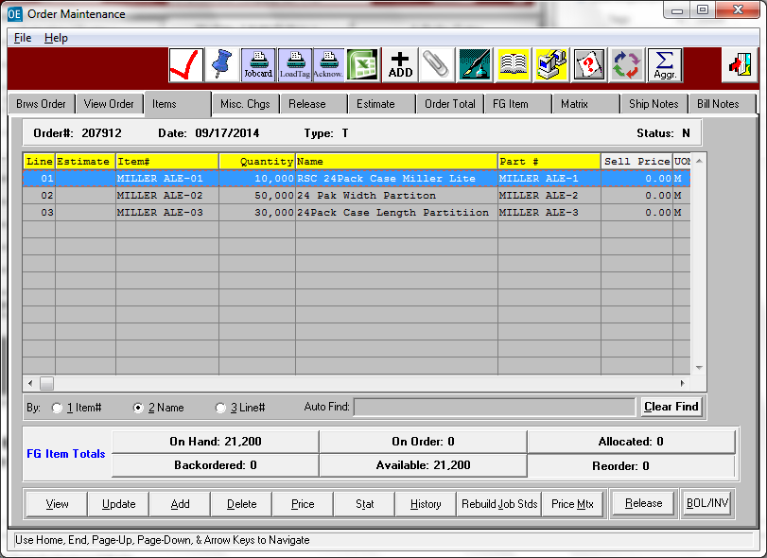

STEP 6  Produce All the Components via normal Manufacturing Processes

Original Assembled Order for Customer.

Data Collection, Load Tags, Finished Goods Receipts, etc.

STEP 7  Menu O-U-1  Release the Components and Ship to Vendor Goodwill.

Release Button or BOL/INV button on Items Tab will Release All Items together.

STEP 8  Create and Post Bill of Lading for Components.

Select Inventory / Tags Produced on Manufacturing Order and ship on the TRANSFER ORDER.

STEP 9  Menu O-U-1  Release the Components and Ship to Vendor Goodwill.

This will not create an Invoice.

This will immediately create Finished Goods Transfers.

STEP 10  Menu I-U-1  Receive Assembled Finished Goods from the Vendor.

This will add to On Hand Inventory for the Set’s finished goods item.

This will also reduce the on hand inventory of the components which are displayed as negative adjustments.